**JAVASCRIPT**

1. **Prompt for amount, interest rate and no. of years and calculate simple interest.**

**CODE**

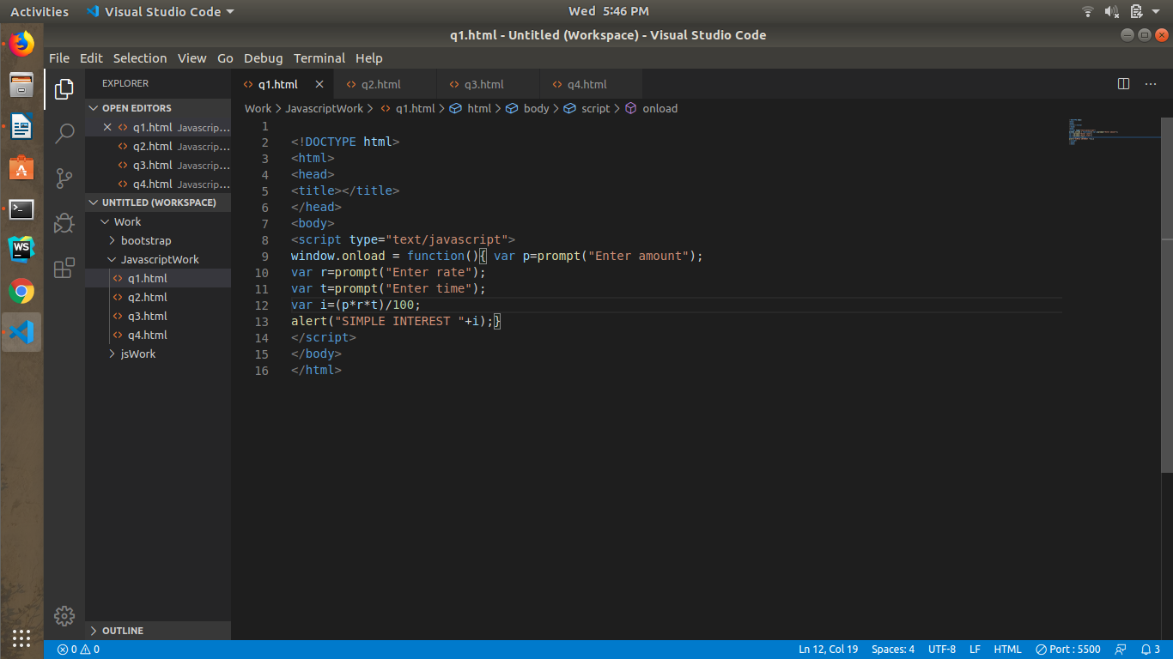

**OUTPUT**

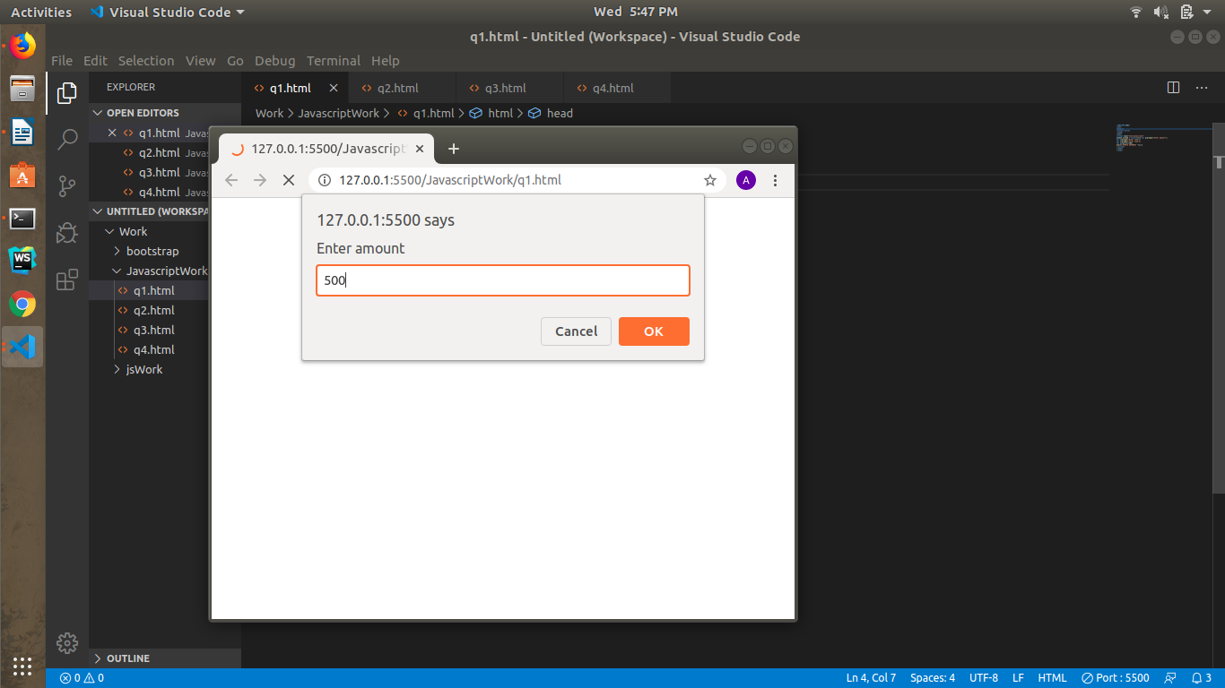

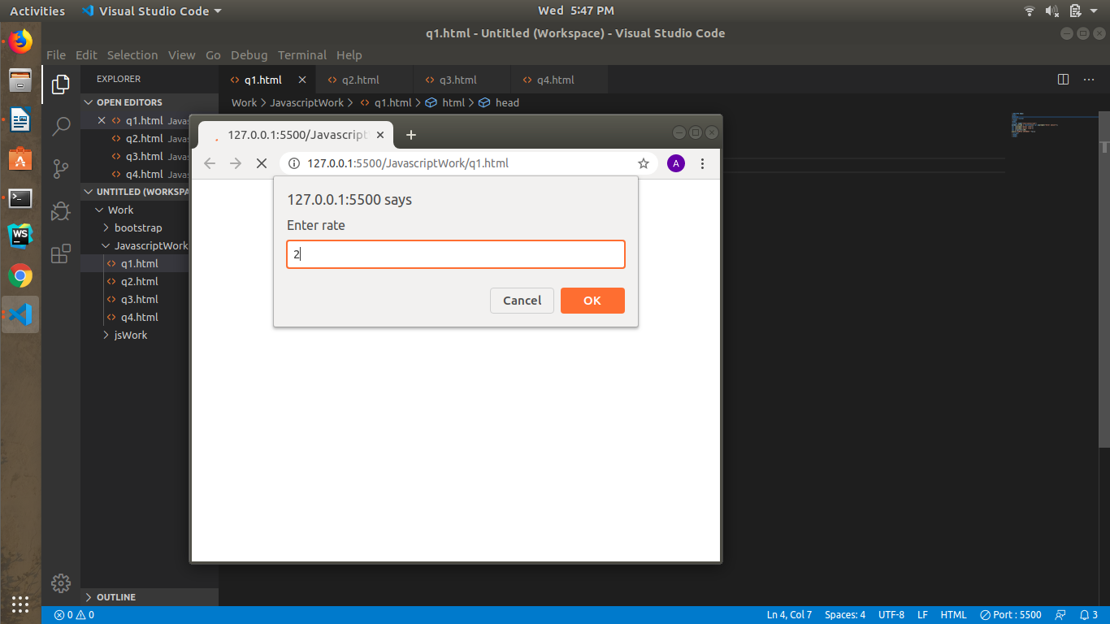

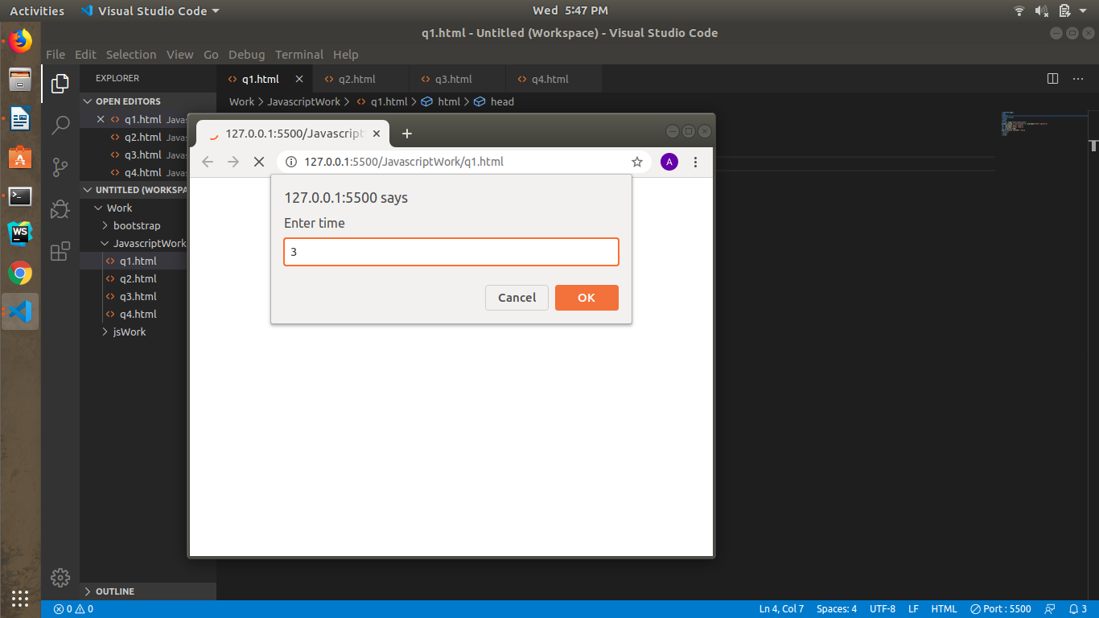

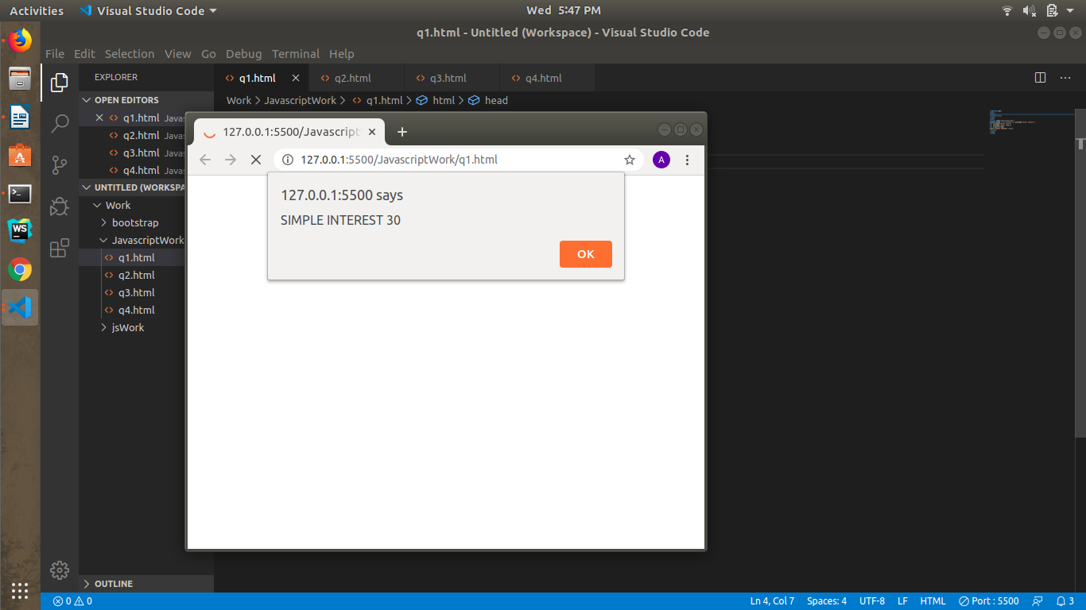

1. **Is palindrome string**

**CODE**

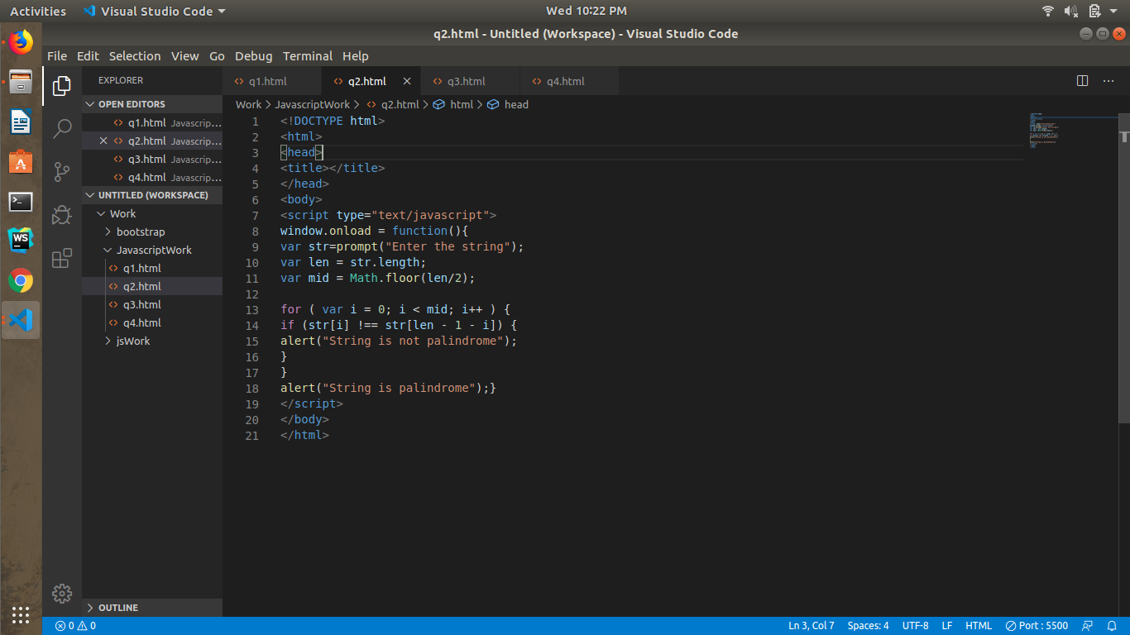

**OUTPUT**

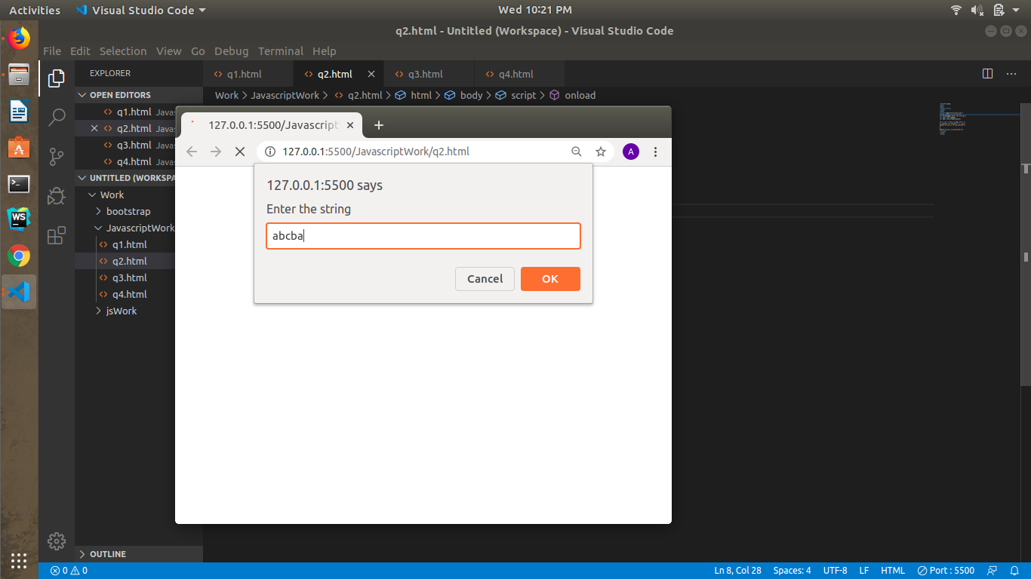

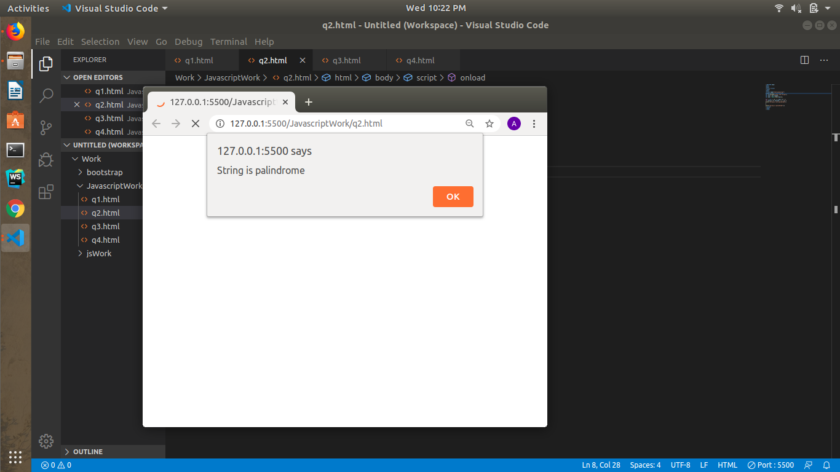

1. **Area of circle**

**CODE**

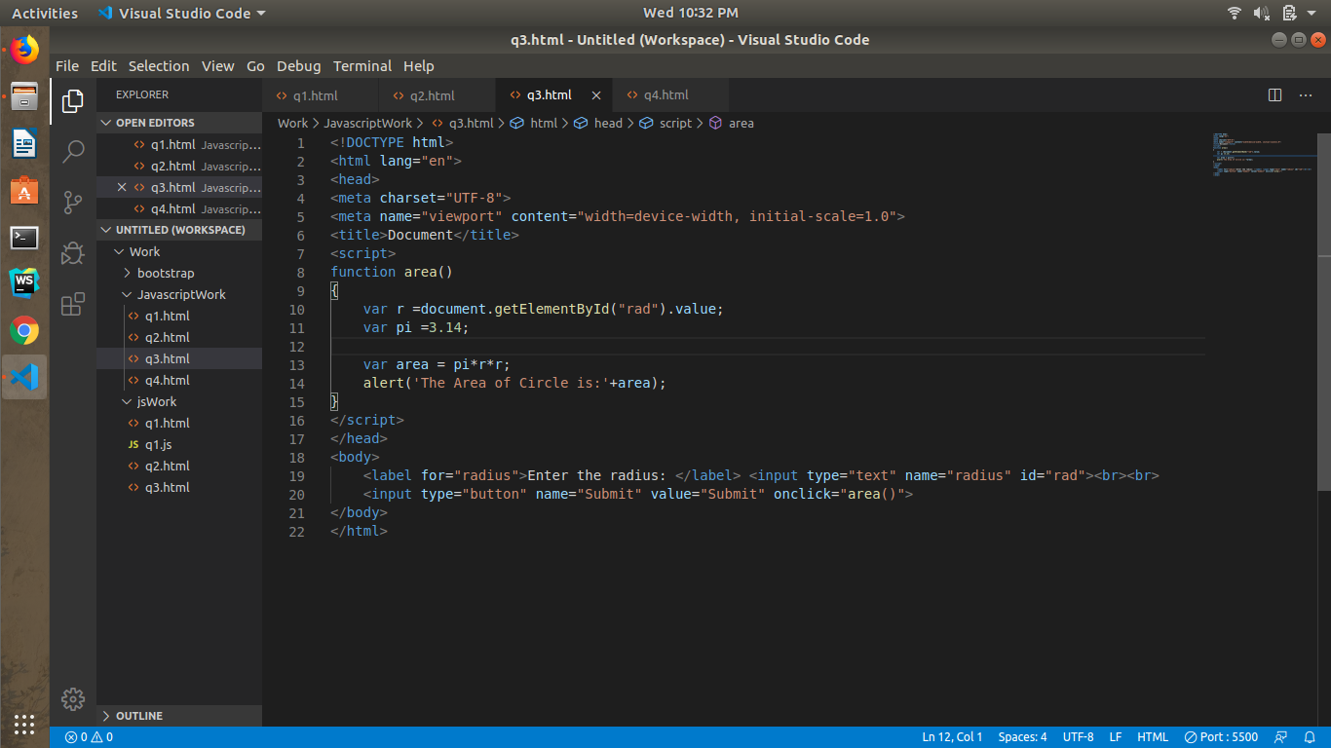

**OUTPUT**

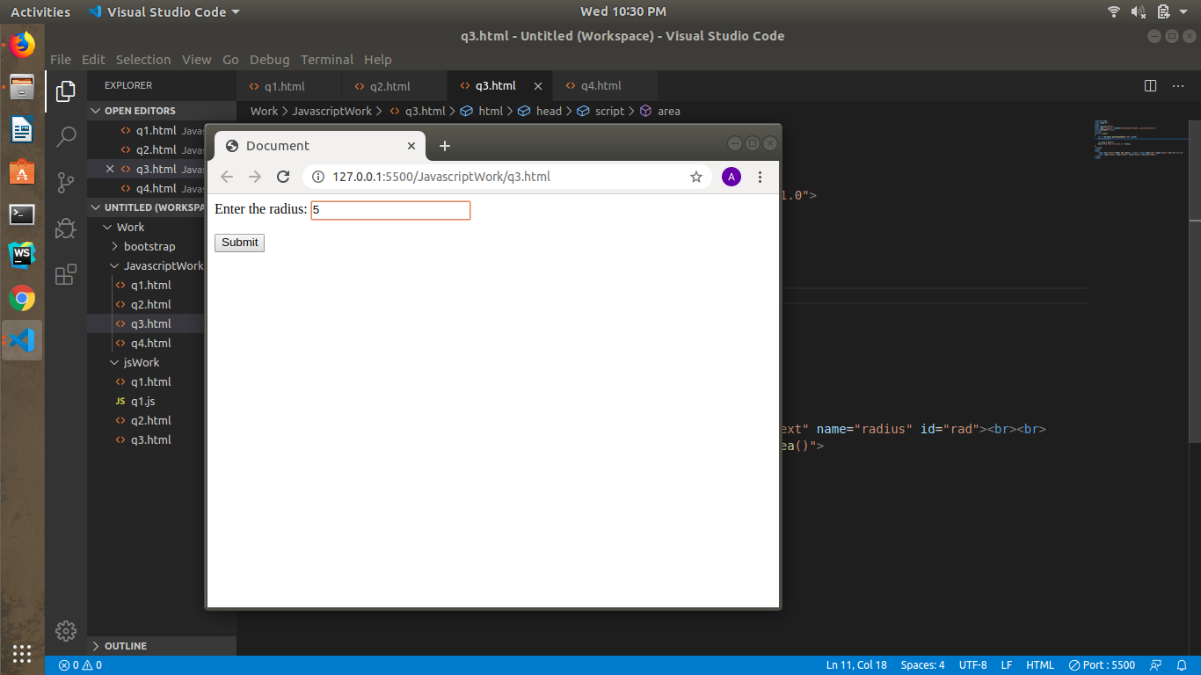

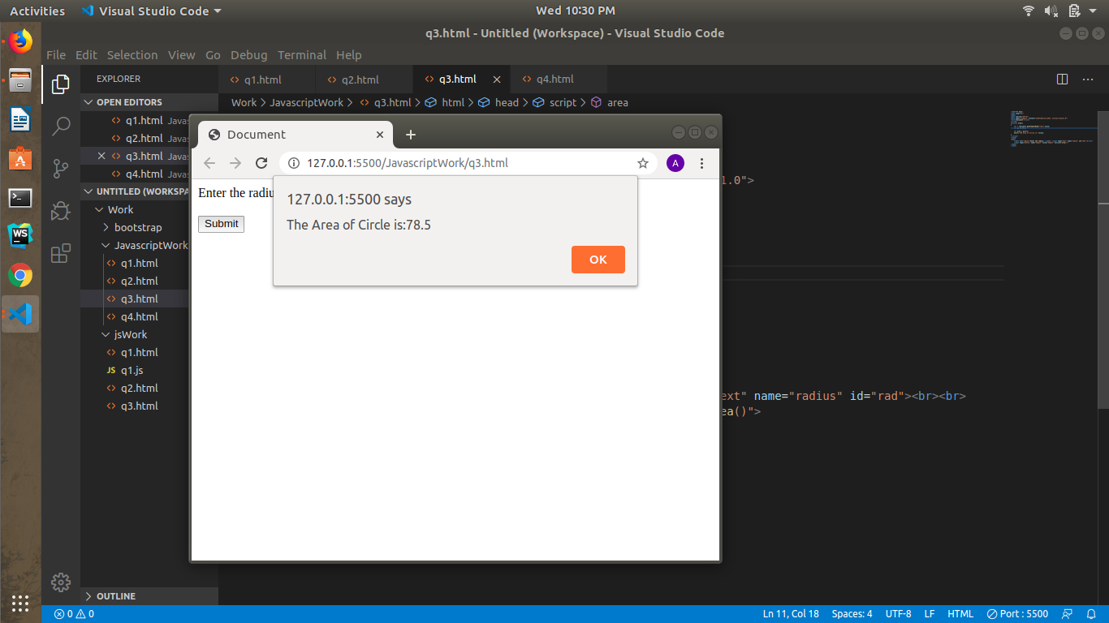

1. **Copy information of one object to another and log it to console.**

**CODY WITHOUT SPREAD OPERATOR**

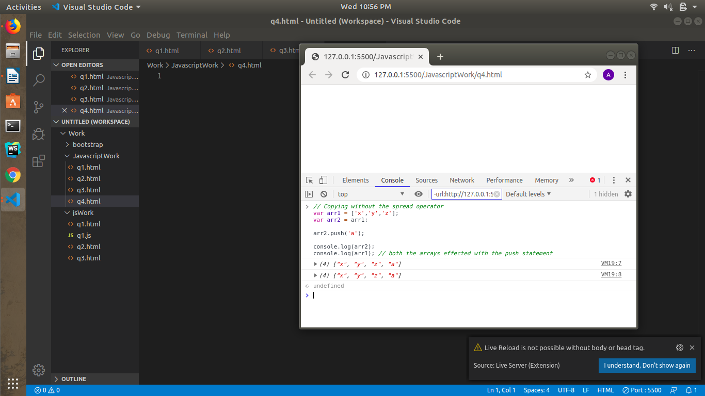

**CODY WITH SPREAD OPERATOR**

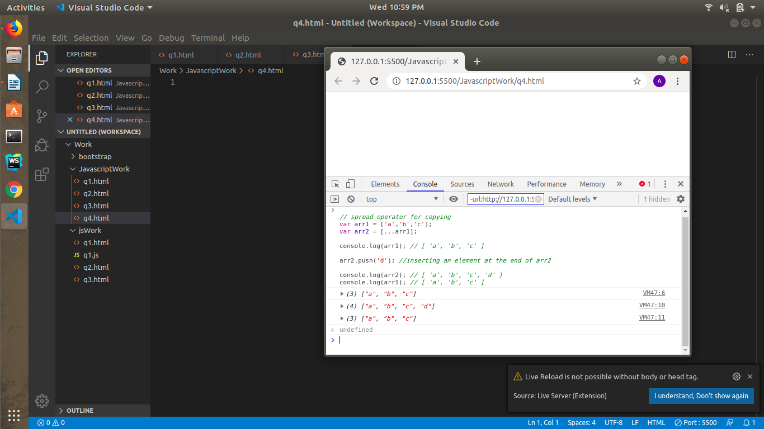

1. **create a list of objects of Employee with info as follow :** 
   * **Name, age, salary ,DOB**
   * **filter all employees with salary greater than 5000**

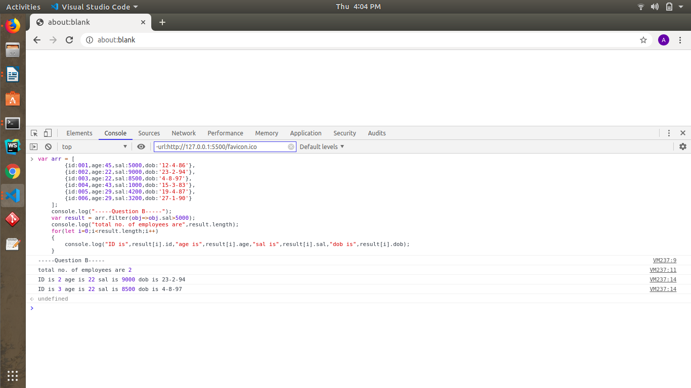

* + **group employee on the basis of their age**

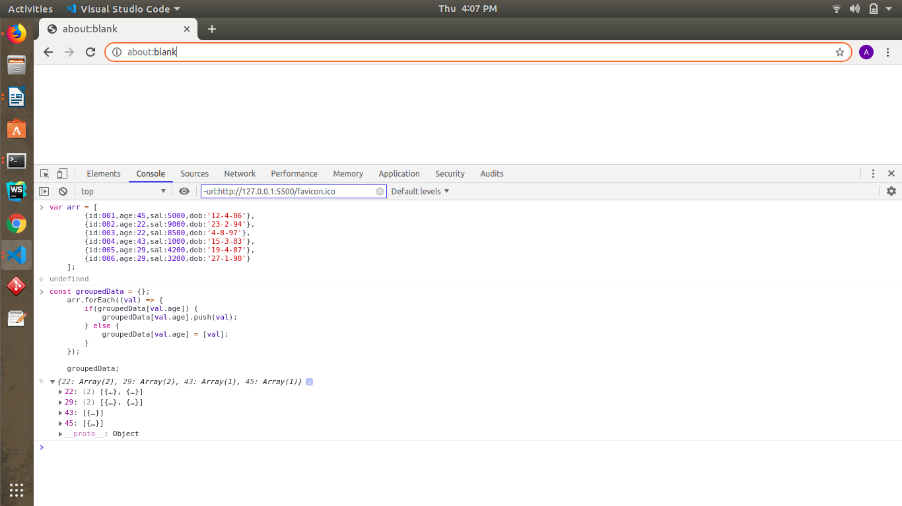

* + **fetch employees with salary less than 1000 and age greater than 20. Then give them an increment 5 times their salary.**

